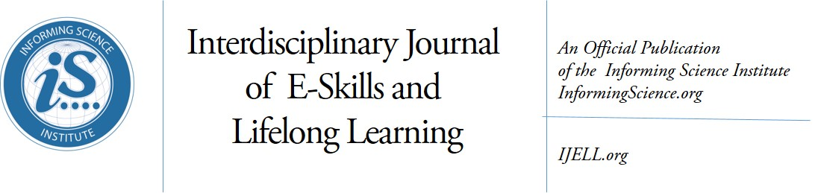
Volume 13, 2017
Editors-in-Chief: Fay Sudweeks, Murdoch University (Australia)
Associate Editor-in-Chief: Janice Whatley, Manchester Metropolitan University (UK)
Associate Editor-in-Chief: Jon K. Webber, University of Phoenix (USA)
Managing Editor: Eli Cohen, Informing Science Institute, California (USA)
Publisher: Elizabeth Boyd, Informing Science Institute, California (USA)

Editors:
Noa Aharony, Bar-Ilan University (Israel)
Nicole A. Buzzetto-More, University of Maryland Eastern Shore, Maryland (USA)
Norman Creaney, University of Ulster, Coleraine (N. Ireland)
Keith Harman, Oakland Baptist University (United States)
William Housel, Northwestern Louisiana State University, Natchitoches (USA)
Fred Kohun, Robert Morris University, Pennsylvania (USA)
Frank Kurzel, University of South Australia, Adelaide (Australia)
Susan Smith Nash, University of Oklahoma, Oklahoma (USA)
Maria Nathan, Lynchburg College, Virginia (USA)
Yehuda Peled, The Western Galilee College (Israel)
Holly Sawyer, Temple University (USA)
Erik Shefsky, Walden University (USA)
Miguel-Angel Sicilia, University of Alcalá, Madrid (Spain)
Robert Skovira, Robert Morris University, Pennsylvania (USA)
Ewa Ziemba, University of Economics in Katowice (Poland)

The Interdisciplinary Journal of e-Skills and Lifelong Learning: (IJELL) is a peer-reviewed journal that publishes scholarly articles on the development of electronic skills and lifelong learning.
This includes using various technologies to develop e-skills and to support lifelong learning. In addition, articles with a sound underpinning of pedagogical principles and design science, on the development of eskills using information technology are also welcome. The journal publishes conceptual, theoretical and empirical papers.
All manuscripts are submitted and reviewed electronically. We provide our published authors with both a quality print publication and the widespread readership that comes from publishing all articles online within a few weeks of acceptance. This approach ensures that published works are read and cited by the widest possible audience
IJELL is an academically peer reviewed Journal. All submissions are blind refereed by three or more peers. IJELL is published in print by subscription and its articles also appear online free of charge on the web site http://ijell.org

IJELL is listed in Cabell’s Directory of Publishing Opportunities in Educational Technology & Library Science, Cabell’s Directory of Publishing Opportunities in Educational Curriculum & Methods, Directory of Open Access Journals (DOAJ), EBSCO, Index of Information Systems Journals, Intute, Ulrichs.

(CC BY-NC 4.0) The articles in this journal are licensed under a Creative Commons Attribution-NonCommercial 4.0 International License. When you copy and redistribute this paper in full or in part, you need to provide proper attribution to it to ensure that others can later locate this work (and to ensure that others do not accuse you of plagiarism). You may (and we encourage you to) adapt, remix, transform, and build upon the material for any non-commercial purposes. This license does not permit you to use this material for commercial purposes.

ISSN: online 2375-2092; print 2375-2084
ISBN: 978-1-68110-023-4
Published by the Informing Science Institute
131 Brookhill Ct., Santa Rosa, California USA
phone: +1-707-537-2211; fax: +1-815-301-6785
http://informingscience.org

Interdisciplinary Journal of e-Skills and Lifelong Learning: IJELL
Volume 13, 2017 – Table of Contents

Medical Community of Inquiry: A Diagnostic Tool for Learning, Assessment, and Research
Rachel Nave, Rakefet Ackerman, and Yehudit Judy Dori 1-17
Making Sense of the Information Seeking Process of Undergraduates in a Specialised University: Revelations from Dialogue Journaling on WhatsApp Messenger
Dorcas Ejemeh Krubu, Sandy Zinn, and Genevieve Hart 19-36
Acquisition among Migrant Women English Learners
Kham Sila Ahmad, Jocelyn Armarego, and Fay Sudweeks 37-57
The Impact of e-Skills on the Settlement of Iranian Refugees in Australia
Saeed Shariati, Jocelyn Armarago, and Fay Sudweeks 59-77
Enhanced Critical Thinking Skills through Problem-Solving Games in Secondary Schools
Scott Douglas McDonald 79-96
Let’s Tell a Story Together
Karishma Kelsey and Andrew Zaliwski 97-115
Closing the Digital Divide in Low-Income Urban Communities: A Domestication Approach
Patrick Kanyi Wamuyu 117-142

