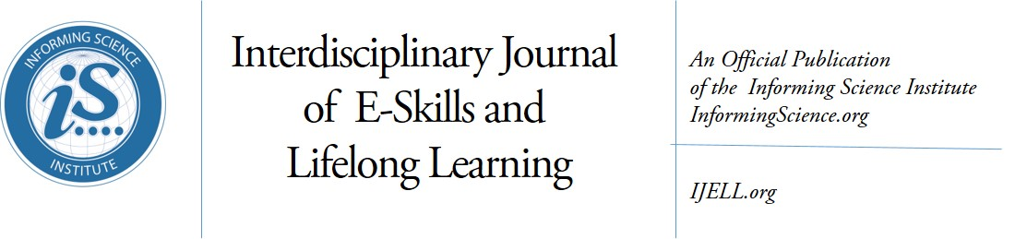
Volume 14, 2018

Editor-in-Chief: Fay Sudweeks, Murdoch University (Australia)
Associate Editor-in-Chief: Jon K. Webber, University of Phoenix (USA)
Managing Editor: Eli Cohen, Informing Science Institute, California (USA)
Publisher: Elizabeth Boyd, Informing Science Institute, California (USA)

Editors:
Noa Aharony, Bar-Ilan University (Israel)
Nicole A. Buzzetto-Hollywook, University of Maryland Eastern Shore, Maryland (USA)
Fred Kohun, Robert Morris University, Pennsylvania (USA)
Yehuda Peled, The Western Galilee College (Israel)
Holly Sawyer, Temple University (USA)
Erik Shefsky, Walden University (USA)
Janice Whatley, Manchester Metropolitan University (UK)
Ewa Ziemba, University of Economics in Katowice (Poland)

The Interdisciplinary Journal of e-Skills and Lifelong Learning: (IJELL) is a peer-reviewed journal that publishes scholarly articles on the development of electronic skills and lifelong learning.
This includes using various technologies to develop e-skills and to support lifelong learning. In addition, articles with a sound underpinning of pedagogical principles and design science, on the development of e-skills using information technology are also welcome. The journal publishes conceptual, theoretical and empirical papers.
All manuscripts are submitted and reviewed electronically. We provide our published authors with both a quality print publication and the widespread readership that comes from publishing all articles online within a few weeks of acceptance. This approach ensures that published works are read and cited by the widest possible audience
IJELL is an academically peer reviewed Journal. All submissions are blind refereed by three or more peers. IJELL is published in print by subscription and its articles also appear online free of charge on the web site http://ijell.org

IJELL is listed in Cabell’s Directory of Publishing Opportunities in Educational Technology & Library Science, Cabell’s Directory of Publishing Opportunities in Educational Curriculum & Methods, Directory of Open Access Journals (DOAJ), EBSCO, Index of Information Systems Journals, Intute, Ulrichs.

(CC BY-NC 4.0) The articles in this journal are licensed under a Creative Commons Attribution-NonCommercial 4.0 International License. When you copy and redistribute this paper in full or in part, you need to provide proper attribution to it to ensure that others can later locate this work (and to ensure that others do not accuse you of plagiarism). You may (and we encourage you to) adapt, remix, transform, and build upon the material for any non-commercial purposes. This license does not permit you to use this material for commercial purposes.

ISSN: online 2375-2092; print 2375-2084
ISBN: 978-1-68110-032-6
Published by the Informing Science Institute
131 Brookhill Ct., Santa Rosa, California USA
phone: +1-707-537-2211; fax: +1-815-301-6785
http://informingscience.org

Interdisciplinary Journal of e-Skills and Lifelong Learning: IJELL
Volume 14, 2018 – Table of Contents

Work-Based Learning and Research for Mid-Career Professionals: Professional Studies in Australia
Lee Fergusson, Tim Allred, Troy Dux 1-17
Work-Based Learning and Research for Mid-Career Professionals: Two Project Examples from Australia
Lee Fergusson, Tim Allred, Troy Dux, Hugo Muianga 19-40
An Examination of Gen Z Learners Attending a Minority University
Nicole Buzzetto-Hollywood, Ayodele Alade 41-53
South Africa’s Quest for Smart Cities: Privacy Concerns of Digital Natives of Cape Town,
South Africa
Valerie Tshiani, Maureen Tanner 55-76
Addressing Information Literacy and the Digital Divide in Higher Education
Nicole Buzzetto-Hollywood, Hwei Wang, Magdi Elobeid, Muna Elobaid 77-93
Performance Expectancy, Effort Expectancy, and Facilitating Conditions as Factors Influencing Smart Phones Use for Mobile Learning by Postgraduate Students of the University of Ibadan, Nigeria
Sodiq Onaolapo, Olawale Oyewole 95-115
21st Century Skills: Student Perception of Online Instructor Role
Asmaa Ganayem, Wafa Zidan 117-141
Students’ Approaches to E-Learning: Analyzing Credit/Noncredit and High/Low Performers
Gwen Nugent, Ashu Guru, Deana Namuth-Covert 143-158
Plagiarism Management: Challenges, Procedure, and Workflow Automation
Angelos Rodafinos 159-175
E-Safety in the Use of Social Networking Apps by Children, Adolescents, and Young Adults
Gila Cohen Zilka 177-190

