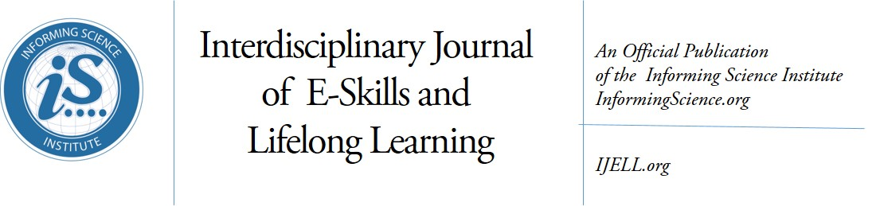
Volume 15, 2019

Editor-in-Chief: Fay Sudweeks, Murdoch University (Australia)
Associate Editor-in-Chief: Jon K. Webber, University of Phoenix (USA)
Managing Editor: Eli Cohen, Informing Science Institute, California (USA)
Publisher: Elizabeth Boyd, Informing Science Institute, California (USA)

Editors:
Noa Aharony, Bar-Ilan University (Israel)
Nicole A. Buzzetto-Hollywook, University of Maryland Eastern Shore, Maryland (USA)
Fred Kohun, Robert Morris University, Pennsylvania (USA)
Yehuda Peled, The Western Galilee College (Israel)
Holly Sawyer, Temple University (USA)
Erik Shefsky, Walden University (USA)
Janice Whatley, Manchester Metropolitan University (UK)
Ewa Ziemba, University of Economics in Katowice (Poland)

The Interdisciplinary Journal of e-Skills and Lifelong Learning: (IJELL) is a peer-reviewed journal that publishes scholarly articles on the development of electronic skills and lifelong learning.
This includes using various technologies to develop e-skills and to support lifelong learning. In addition, articles with a sound underpinning of pedagogical principles and design science, on the development of e-skills using information technology are also welcome. The journal publishes conceptual, theoretical and empirical papers.
All manuscripts are submitted and reviewed electronically. We provide our published authors with both a quality print publication and the widespread readership that comes from publishing all articles online within a few weeks of acceptance. This approach ensures that published works are read and cited by the widest possible audience
IJELL is an academically peer reviewed Journal. All submissions are blind refereed by three or more peers. IJELL is published in print by subscription and its articles also appear online free of charge on the web site http://ijell.org

IJELL is listed in Cabell’s Directory of Publishing Opportunities in Educational Technology & Library Science, Cabell’s Directory of Publishing Opportunities in Educational Curriculum & Methods, Directory of Open Access Journals (DOAJ), EBSCO, Index of Information Systems Journals, Intute, Ulrichs.

(CC BY-NC 4.0) The articles in this journal are licensed under a Creative Commons Attribution-NonCommercial 4.0 International License. When you copy and redistribute this paper in full or in part, you need to provide proper attribution to it to ensure that others can later locate this work (and to ensure that others do not accuse you of plagiarism). You may (and we encourage you to) adapt, remix, transform, and build upon the material for any non-commercial purposes. This license does not permit you to use this material for commercial purposes.

ISSN: online 2375-2092; print 2375-2084
ISBN: 978-1-68110-043-2
Published by the Informing Science Institute
131 Brookhill Ct., Santa Rosa, California USA
phone: +1-707-537-2211; fax: +1-815-301-6785
http://informingscience.org

Interdisciplinary Journal of e-Skills and Lifelong Learning: IJELL
Volume 15, 2019 – Table of Contents

Students’ Perceptions of Benefits and Drawbacks of Facebook-Connections with Teachers
Arnon Hershkovitz, Alona Forkosh-Baruch 1-20
Faculty and Student Perceptions of the Importance of Management Skills in the Hospitality Industry
Katherine Quinn, Nicole Buzzetto-Hollywood 21-41
Remaining Connected with our Graduates: A Pilot Study
Joy Penman, Eddie Robinson, Wendy Cross 43-57
Knowing Me, Knowing You: Teachers’ Perceptions of Communication with their Students
on Facebook
Alona Forkosh-Baruch, Arnon Hershkovitz 59-80
Positive vs. Negative Framing of Scientific Information on Facebook Using Peripheral Cues:
An Eye tracking Study of the Credibility Assessment Process
Aviad Rotboim, Arnon Hershkovitz, Eddie Laventman 81-103
The Impact of Preservice and New Teachers’ Involvement in Simulation Workshop and Their Perceptions about the Concept of Conflict in Education
Esmael Salman, Amtiaz Fattum 105-120

